 | 12.1.39 Editors - Geometry Nodes Editor - Header - Add Menu - Volume - Operations
Table of content
Detailed table of content 1
Add menu - Volume - Operations 4
Grid to Mesh 4
Volume to Mesh 4
SDF Grid Boolean 5
SDF Grid Fillet 6
SDF Grid Laplacian 6
SDF Grid Mean 6
SDF Grid Mean 7
SDF Grid Median 7
SDF Grid Offset 8
Field to Grid 8
Prune Grid 9
Prune Grid 10

Detailed table of content
Detailed table of content
Detailed table of content 1
Add menu - Volume - Operations 4
Grid to Mesh 4
Inputs 4
Grid 4
Threshold 4
Adaptivity 4
Output 4
Mesh 4
Volume to Mesh 4
Inputs 5
Volume 5
Resolution 5
Threshold 5
Adaptivity 5
Output 5
Mesh 5
SDF Grid Boolean 5
Inputs 5
Grid 1 5
Grid 2 5
Properties 5
Operation 5
Output 5
Grid 5
SDF Grid Fillet 6
Inputs 6
Grid 6
Iterations 6
Output 6
Grid 6
SDF Grid Laplacian 6
Inputs 6
Grid 6
Iterations 6
Output 6
Grid 6
SDF Grid Mean 6
Inputs 7
Grid 7
Width 7
Iterations 7
Output 7
Grid 7
SDF Grid Mean 7
Inputs 7
Grid 7
Iterations 7
Output 7
Grid 7
SDF Grid Median 7
Inputs 8
Grid 8
Width 8
Iterations 8
Output 8
Grid 8
SDF Grid Offset 8
Inputs 8
Grid 8
Distance 8
Output 8
Grid 8
Field to Grid 8
Inputs 8
Topology 8
Properties 9
Data Type 9
Output 9
Grid 9
Prune Grid 9
Inputs 9
Grid 9
Mode 9
Inactive 9
Threshold 9
SDF 9
Properties 9
Data Type 9
Output 10
Grid 10
Prune Grid 10
Inputs 10
Grid 10
Properties 10
Data Type 10
Output 10
Grid 10

´

Add menu - Volume - Operations

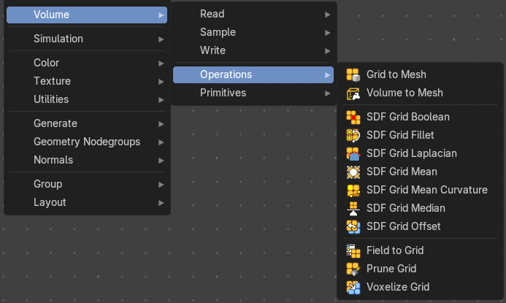
Here you find nodes to modify the volume.

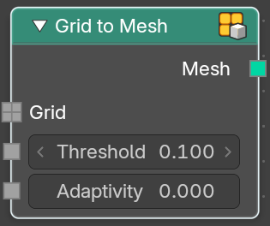
Grid to Mesh
Generate a mesh on the surface of a volume grid.

Inputs

Grid
Standard grid input.

Threshold
Values larger than the threshold are inside the generated mesh.

Adaptivity
The input radius

Output

Mesh
The generated mesh.

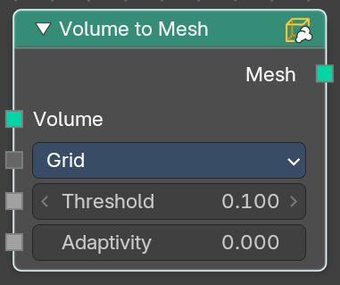
Volume to Mesh
The Volume to Mesh node generates a mesh on the “surface” of a volume. The surface is defined by a threshold value. All voxels with a larger value than the threshold are considered to be outside.
Note that currently this node only works on volumes generated using geometry nodes.

Inputs

Volume
Standard geometry input.

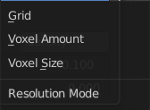
Resolution
Base the voxel resolution at the gridsize, the amount or the size of the point cloud.

Threshold
The voxel amount to use.

Adaptivity
The input radius.

Output

Mesh
The generated mesh.

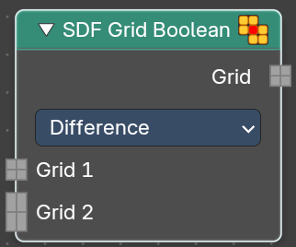
SDF Grid Boolean
Bool multiple sdf grids with each other.

Inputs

Grid 1
The first input grid.

Grid 2
The second input grid

Properties

Operation
The bool method.

Output

Grid
The generated grid.

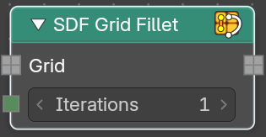
SDF Grid Fillet
Round off concave internal corners in a signed distance field. Only affects areas with negataive principal curvature. This creates smoother transitions between surfaces.

Inputs

Grid
The input grid.

Iterations
How often to run the algorithm.

Output

Grid
The generated grid.

SDF Grid Laplacian
Apply laplacian flow smoothing to a signed distance field.

Inputs

Grid
The input grid.

Iterations
How often to run the algorithm.

Output

Grid
The generated grid.

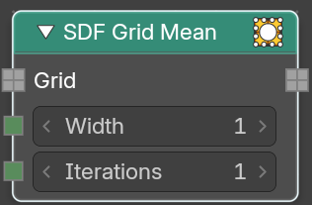
SDF Grid Mean
Apply lmean (box) filter smoothing to a signed distance field. Fast separable averaging filter for general smoothing of the distance field.

Inputs

Grid
The input grid.

Width
Filter kernel radius in voxel.

Iterations
How often to run the algorithm.

Output

Grid
The generated grid.

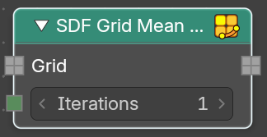
SDF Grid Mean
Apply mean filter smoothing to a signed distance field. Evolves the surface based on its mean curvature. This smooths high curvature regions more than flat areas.

Inputs

Grid
The input grid.

Iterations
How often to run the algorithm.

Output

Grid
The generated grid.

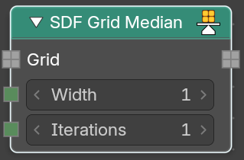
SDF Grid Median
Apply median filter smoothing to a signed distance field. Reduces nioise while preserving sharp features and edges in the distance field.

Inputs

Grid
The input grid.

Width
Filter kernel radius in voxel.

Iterations
How often to run the algorithm.

Output

Grid
The generated grid.

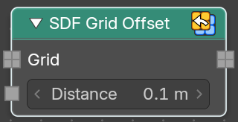
SDF Grid Offset
Offset a signed distance field surface by a world space distance. It dilates or erodes while maintaining the signed distance property.

Inputs

Grid
The input grid.

Distance
Object space distance to offset the sdf surface.

Output

Grid
The generated grid.

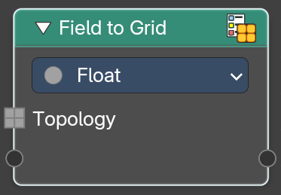
Field to Grid
Create new grids by evaulating new values on an existing volume grid topology.

Inputs

Topology
The input topology.

Properties

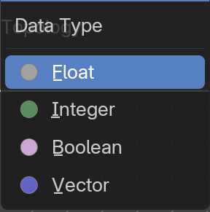
Data Type
The data type to evaluate.

Output

Grid
The generated grid.

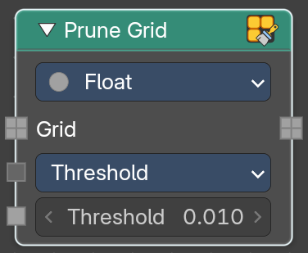
Prune Grid
Create new grids by evaulating new values on an existing volume grid topology.

Inputs

Grid
The input grid.

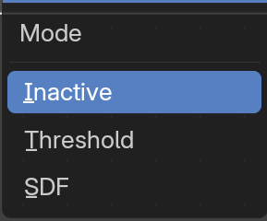
Mode
How to progress the state.

Inactive
Turn inactive voxels and tiels into inactive background tiles.

Threshold
Turn regioons where all voxels have the same value and active state into inactive background tiles. You will see a threshold slider.

SDF
Replace inactive tiles with inactive nodes.

Properties

Data Type
The data type to evaluate.

Output

Grid
The generated grid.

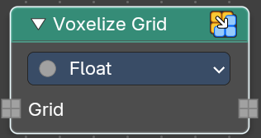
Prune Grid
Create new grids by evaulating new values on an existing volume grid topology.

Inputs

Grid
The input grid.

Properties

Data Type
The data type to evaluate.

Output

Grid
The generated grid.

